**EECS 2311 W20**

**Venn Diagram**

***User Manual***

**GRP - #11**

**MEMBERS**

Tianpei Liao

Arda Temel

Lynn Al Agilly

Jeyaprashanth Sivasubramaniam

**York University**

**Table of Contents**

Getting Started 3

1. Introduction: 3
2. System Requirements: 3
3. Installation instructions: 3

Features and Usage 4

1. Creating New Entries: 4

**I. Manual Creation:** Start by simply clicking the ‘+’ sign. 4

**II. Importing from a File:** Start by Clicking to the File tab on the top right corner menu bar. 6

1. Customizing the Entries: 7
2. Deleting existing entries: 8
3. Drag and Drop feature: 9
4. Entry Categorization: 9
5. Export current system state as image file (.png format): 10
6. Input title for Venn diagram circles 10
7. Create new answer sets for Test Mode: 11
8. Delete existing answer sets 12
9. Submit the answers for evaluation 12
10. Save current state of the application 14
11. Load existing saved file 14
12. Undo and Redo 15

### **Getting Started**

##### Introduction:

The main usage of this application is to organize and visualize data. The software aims to make categorization of information as easy as possible for the user. How it achieves this is by having a user-friendly interface, easily import and export information, being able to move entities around the scene seamlessly, and create delete and edit entries with simple instructions.

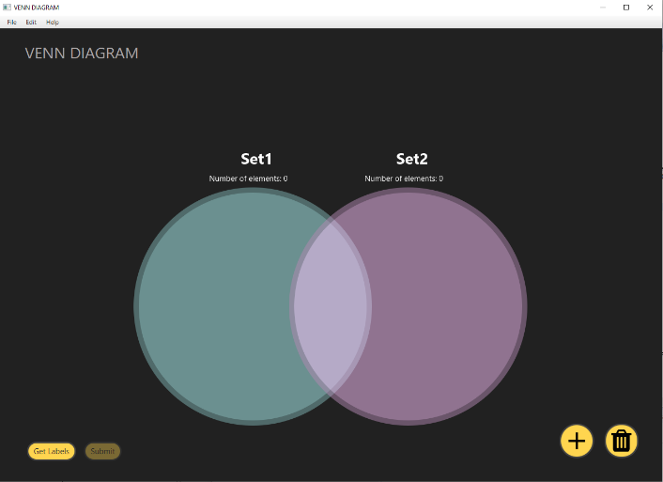

##### System Requirements:

**Windows:** MS OS 7 or above and JDK 1.8 or above

**Mac:** All latest version after 2012

##### Installation instructions:

**Windows:** Double click to the executable jar file to run the application.

**Windows**/**Mac/Linux:** Using Terminal type the following:

- **java -jar filename. Jar**

### **Features and Usage**

##### Creating New Entries:

###### **I. Manual Creation:** Start by simply clicking the ‘+’ sign.

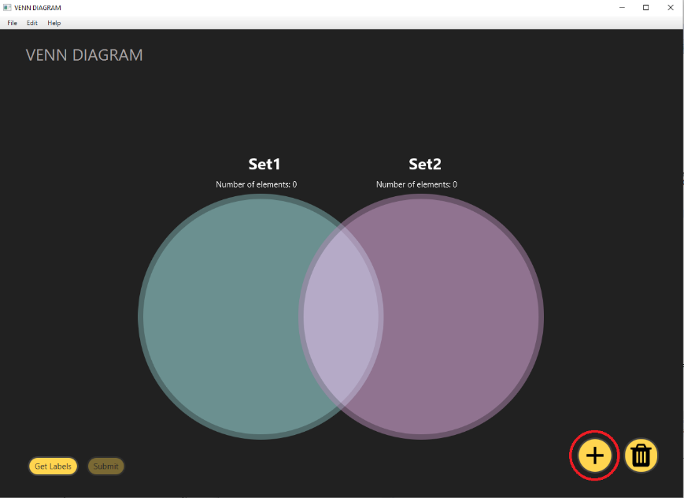

Then In the pop-up window

**Entry Text** - enter the text of the new entry to the text field. Maximum of 10 characters for new entry

**Pick a colour** - use the colour picker drop down menu to pick a colour for entry

**Entry shape** - use the slider to have either rounded borders or cornered

**Entry Description** - add detailed description to entries and when user brings the cursor top of elements will display the description.

Finally press the create button to create a new entry.

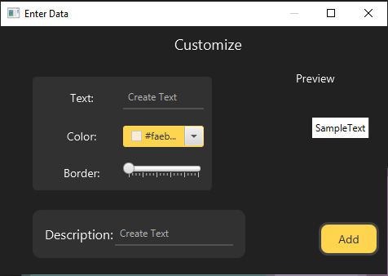

As seen on the example you will have a new entry on the scene.

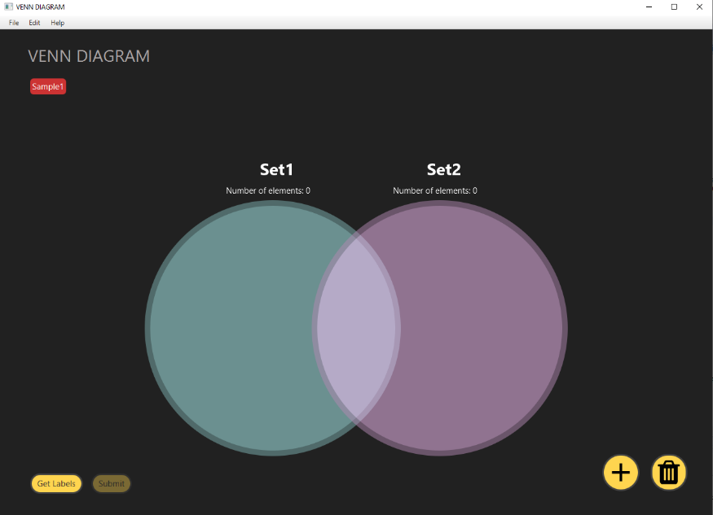

When bring the cursor over the existing entry user able to see the detailed entry description.

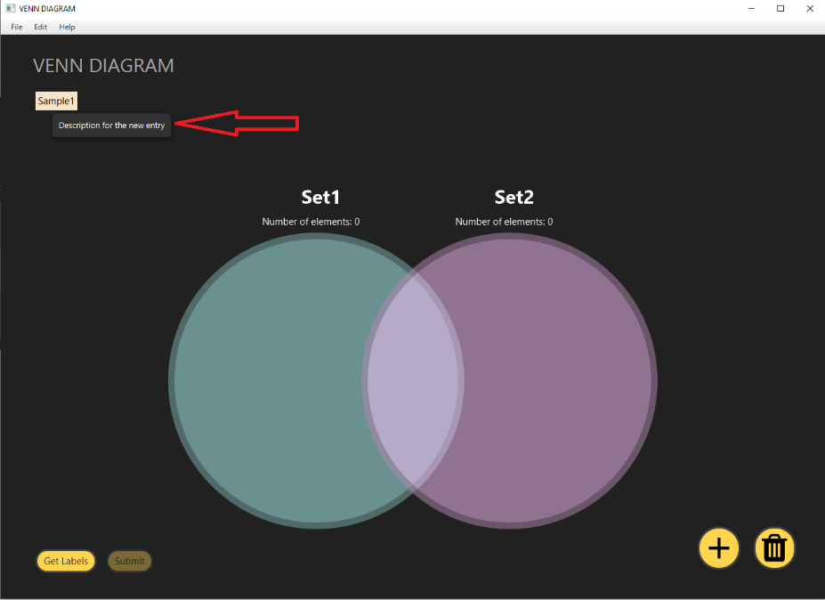

###### **II. Importing from a File:** Start by Clicking to the File tab on the top right corner menu bar.

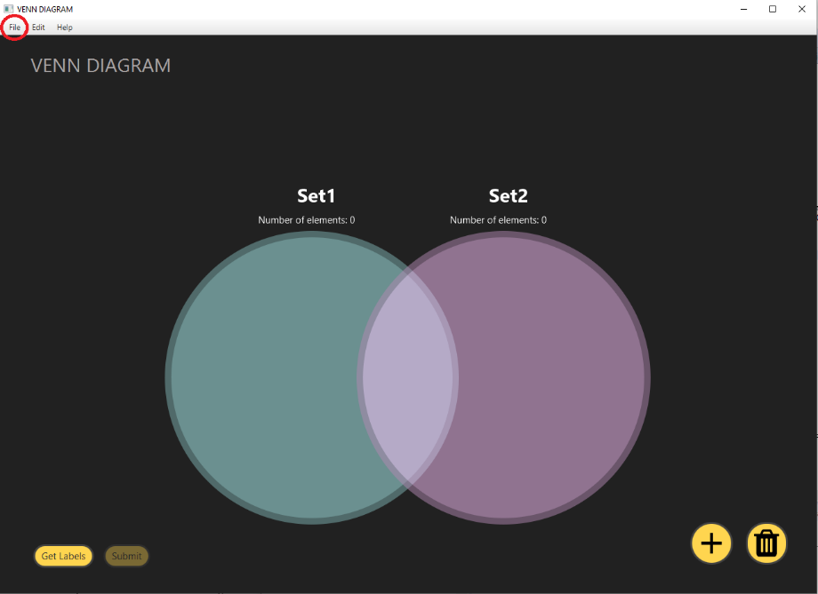

From the Drop-down Menu select the import option and locate the .txt file you want to import.

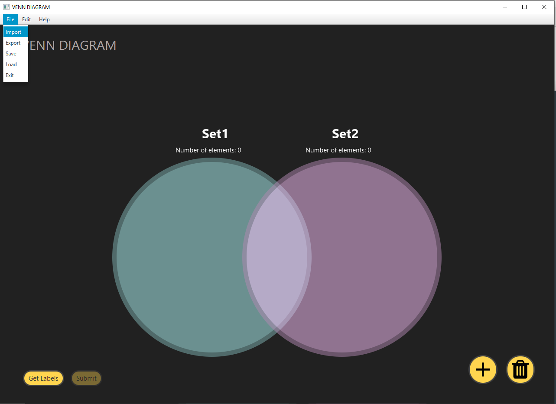

It is important that the .txt file is formatted the right way. Every entry you want to import should be in a new line see the picture below for an example

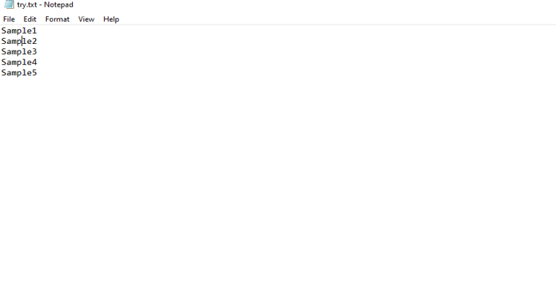

Double click or (select the file and click open button in file explorer) the file you want to import if the file is formatted correctly all the entries should pop up on the main windows with order.

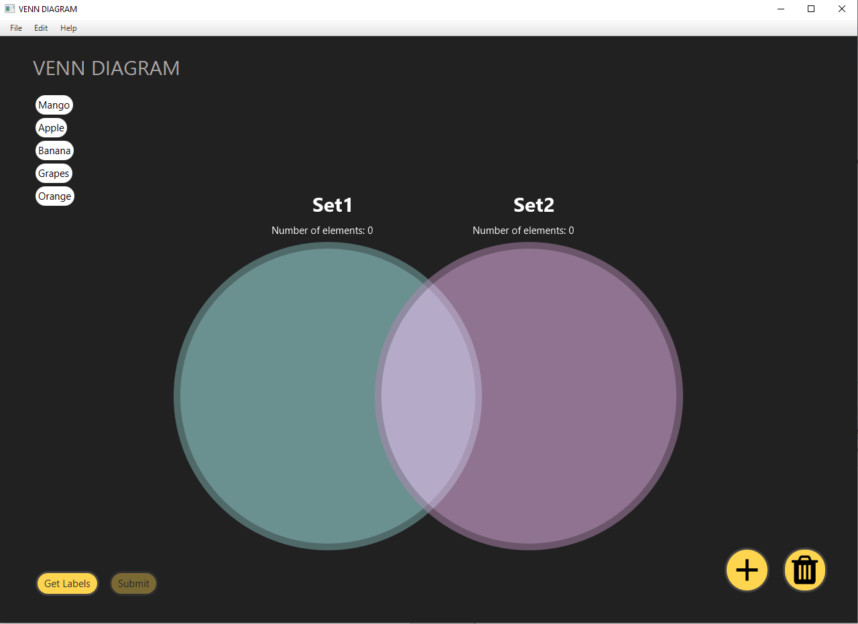

##### Customizing the Entries:

To customize an existing entry simply **double click** it. A new window will pop up. From the window you can change the colour, text, the border radius and description of the entry. The preview window will show a demo of what the edited entry will look like. Click the edit button when done with the customization.

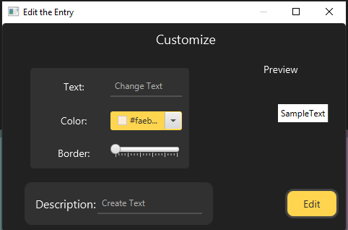

##### Deleting existing entries:

Deleting existing entries by dragging and dropping them on the trash can button at the bottom right corner of the scene**.** User can delete multiple entries at once by press the right mouse and create a rectangle boundary to select the entries then press the backspace button.

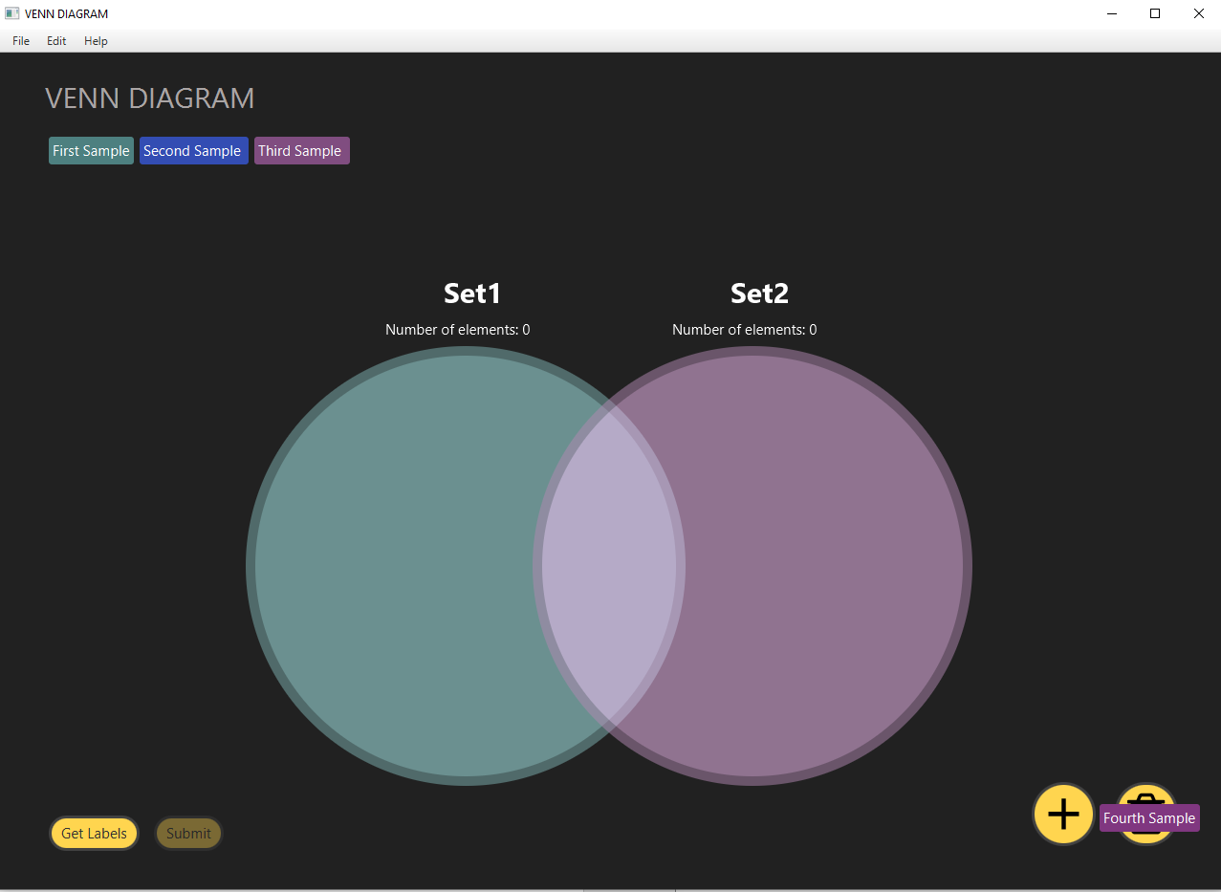

##### Drag and Drop feature:

Every newly created and already existing entry can be dragged and dropped anywhere on the scene. If two entries are on top of each other one of them will move right so users can see every entry on the scene. User can select multiple entries by press right mouse button and create rectangle boundary to cover the entries and drag and drop within the screen.

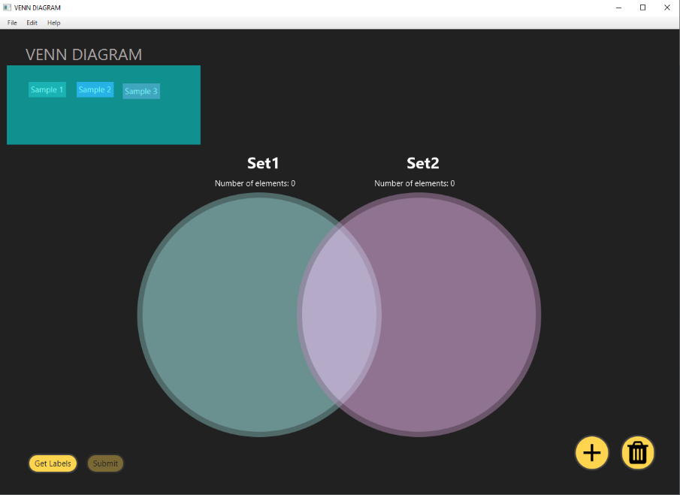

##### Entry Categorization:

Drag entries of the same set to the corresponding circles to start categorizing. When an entry is registered in a set the circle will lit up and the number of elements will go up. If an entry is an element for both sets then drag it where circles intersect. The entry will be registered for both sets and both circles will light up. To remove entry out of a set drag it outside of the circle. If a set has no element the circle won’t be lit up.

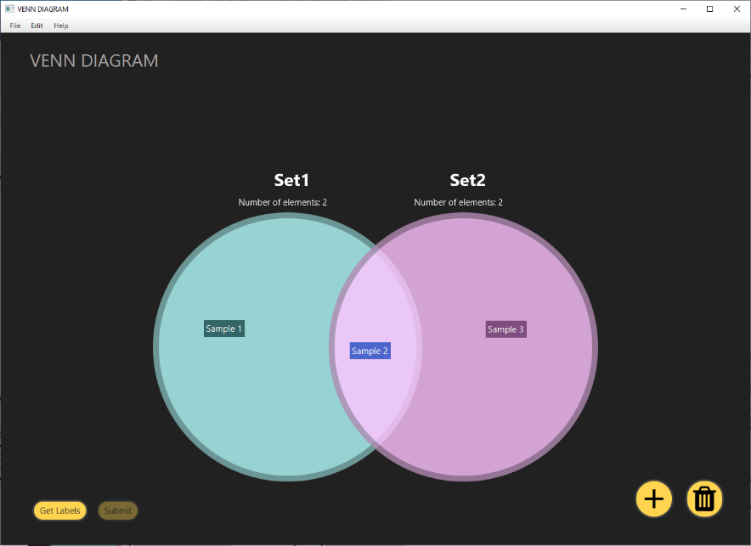

##### Export current system state as image file (.png format):

User can save the system state as image file. After adding entries, select the export option from the file menu then in file opener input a name for new image file name and select a location to save the file. Finally click save. Current system state will be saved as image file (.png format).

##### Input title for Venn diagram circles

User can assign name for each diagram circle. To do that double click the existing title and using title window type the new category name for the circles individually.

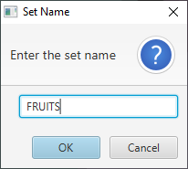

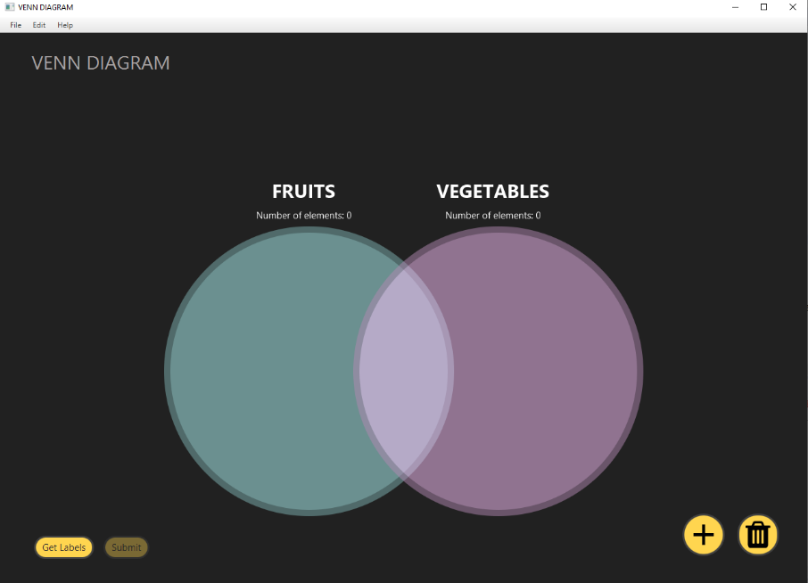

##### Create new answer sets for Test Mode:

User able to create answer sets for Test mode. By creating that system will move from normal mode to Test mode. Created answer label entries will be arranged in random order in Main window.

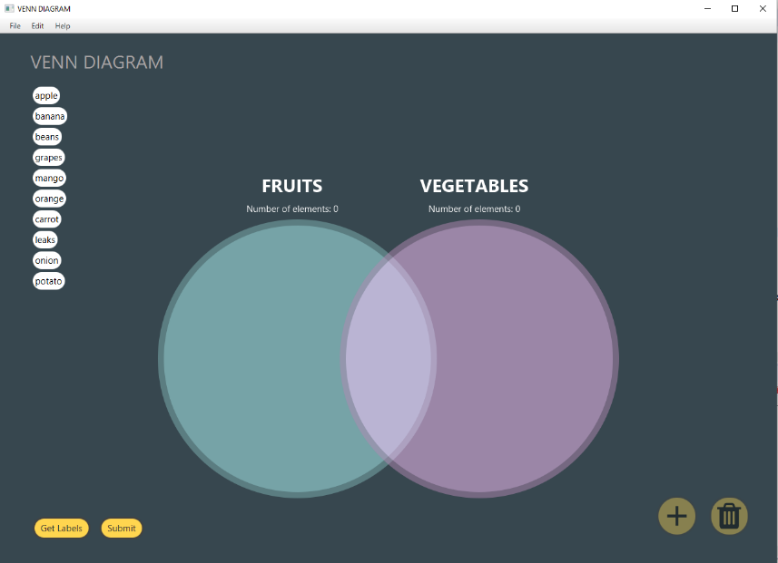

Answer sets can be uploaded from text file but in horizontal order. There are two sets of answers and each words separate by space.

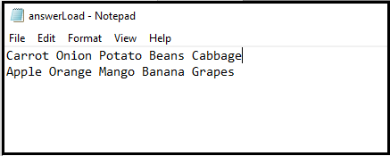

After load the answer the application background colour will change and application in Test Mode. User can replace the current imported answer sets by pressing “Get Labels” button.

User can add additional answer sets to application to expand the Test. To do that user choose “Add Answers” from edit menu and choose text file through file explorer. Additional answer sets will be added with previous answer sets.

When adding answer sets user notify by alert messages and user able to see the instruction for Delete and Adding answer sets.

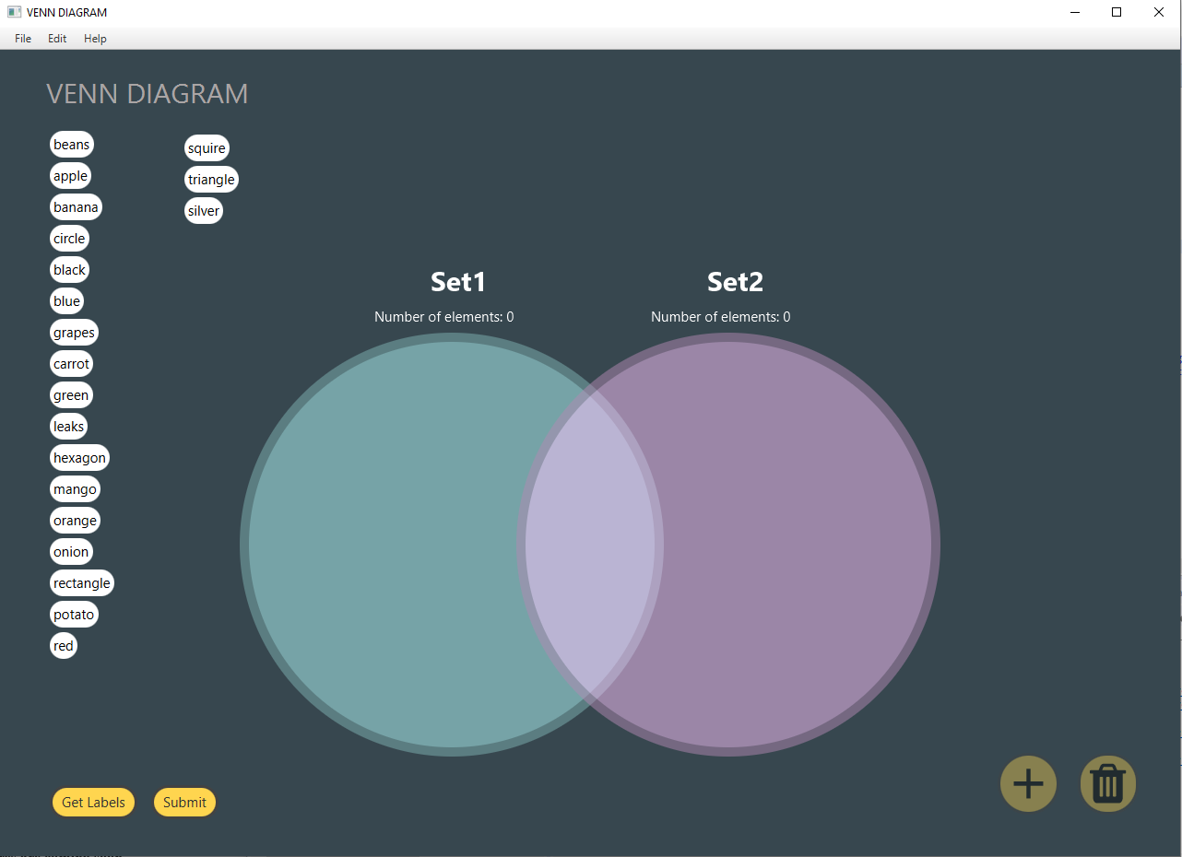

##### Delete existing answer sets

User can delete existing answer sets and exit from the Test Mode to normal mode. To do that choose Edit 🡪 Delete Answers. It will disable the test mode and functions specific for test mode.

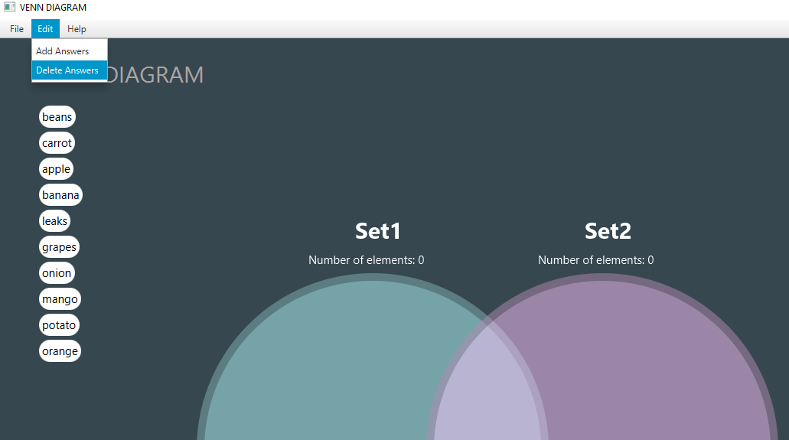

##### Submit the answers for evaluation

Once user complete the test, they can submit the answers by click the submit button. Once answers are submitted, the application will evaluate that answers and if all answers are correct then system will display success message to notify the user.

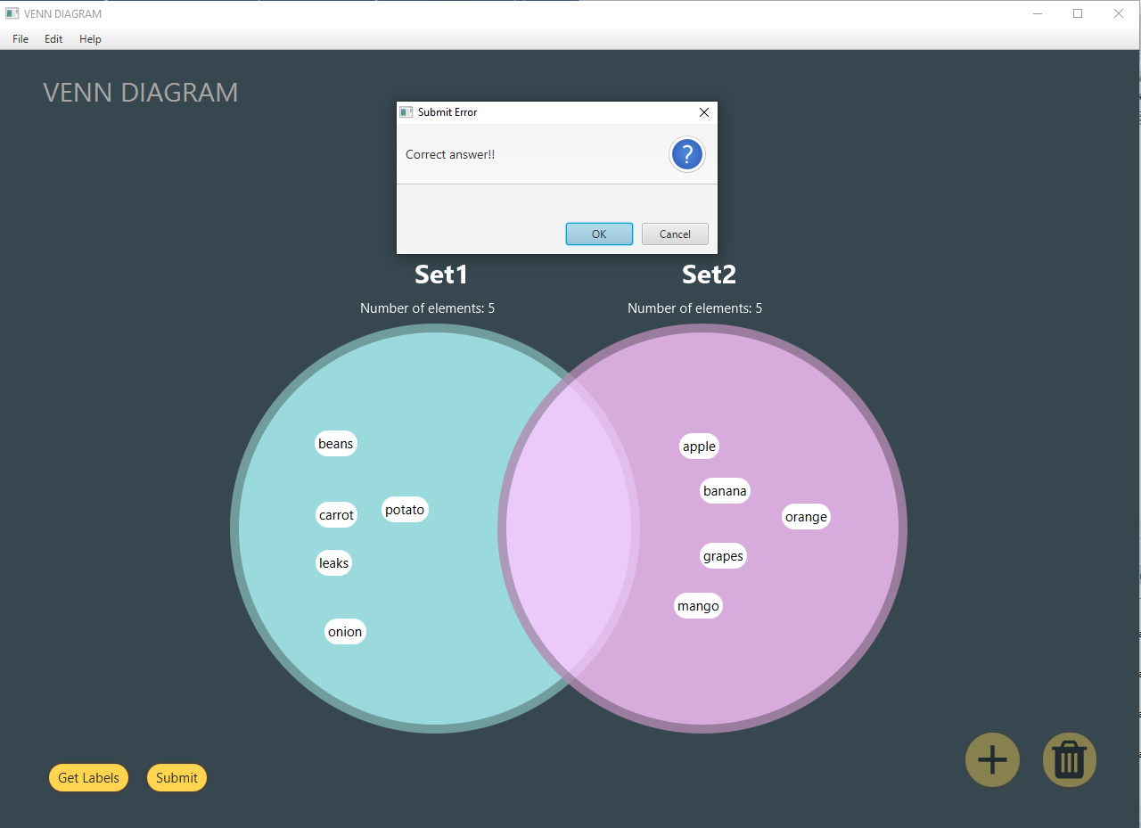

One or more answers are wrong, answer’s background colour will be changed according to the evaluation. Correct 🡪 Green and Wrong 🡪 Red.

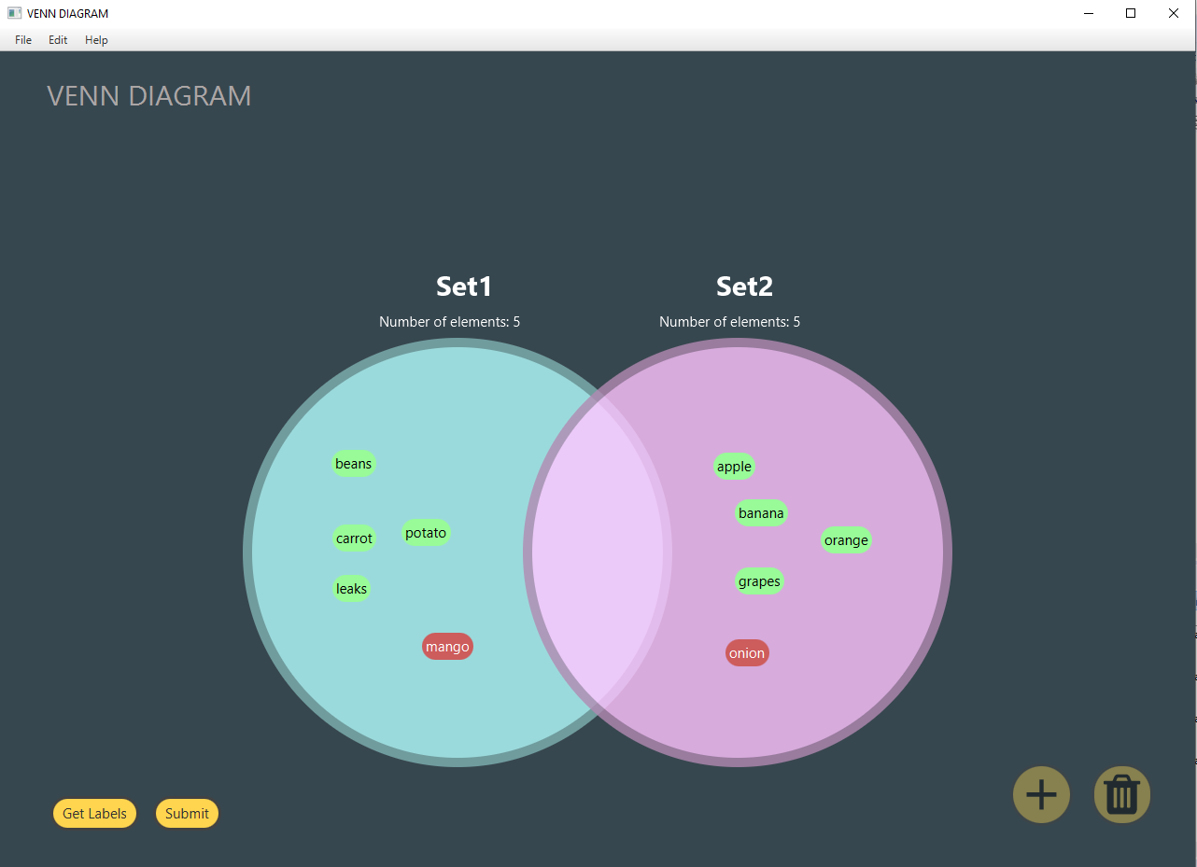

##### Save current state of the application

Application allows user to save their current system state (work) as text file and whenever needed they can load the file and resume working. Saved text file contains each entries’ properties such as text, background colour, shape and description.

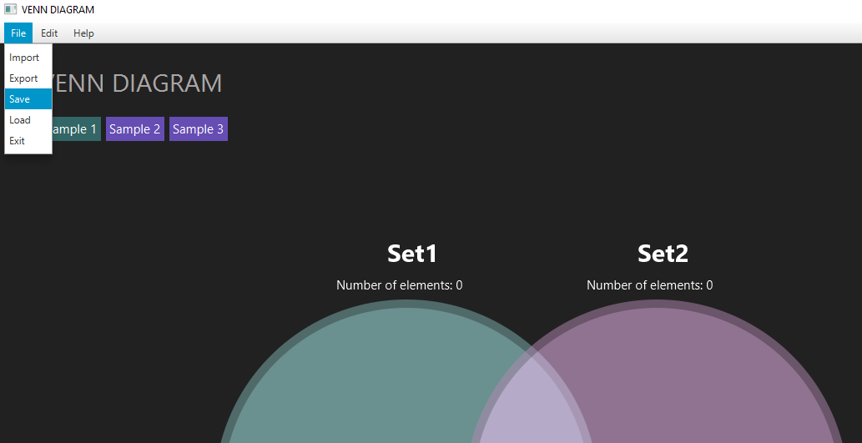

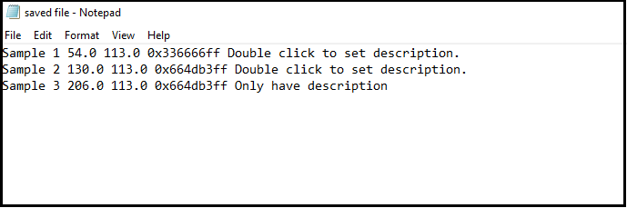

##### Load existing saved file

To continue the previous work application allows the user to load existing saved file and resume working. If the loaded file is empty or does not have all the parameter attributes then system will show an error message. Loaded files in a correct format uploaded entry will be arranged at their exact locations.

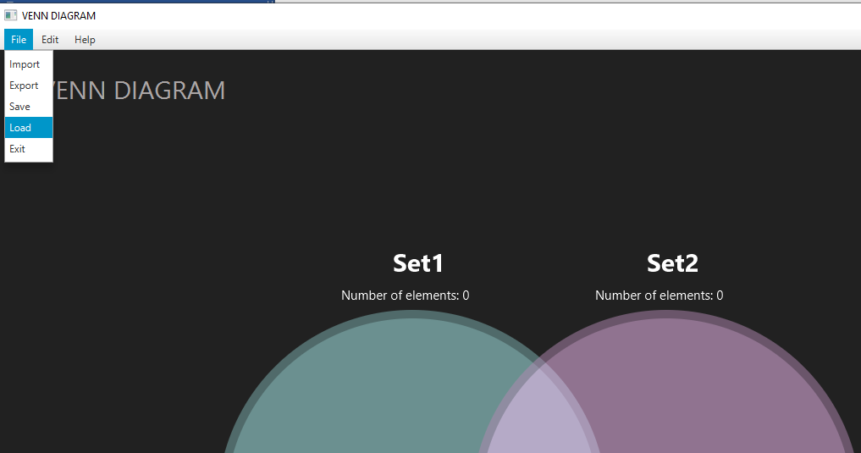

##### Undo and Redo

User can redo and undo their work. Currently this feature only support for the **Add, Delete, Drag, Import** and Load operations. When user do any of the mentioned operation they can undo or redo their operation. An undo operation will retrieve the last state of the system. And redo function does the forward direction operation when system has done at least one undo operation.

We can use keyboard keys to do the undo and redo. Undo 🡪 Z and redo 🡪 X